# Design of “Wildlife wonders”

*by Oleksandr Tunik*

General design of my website pages for both desktop and mobile can be seen in the wireframe model below:

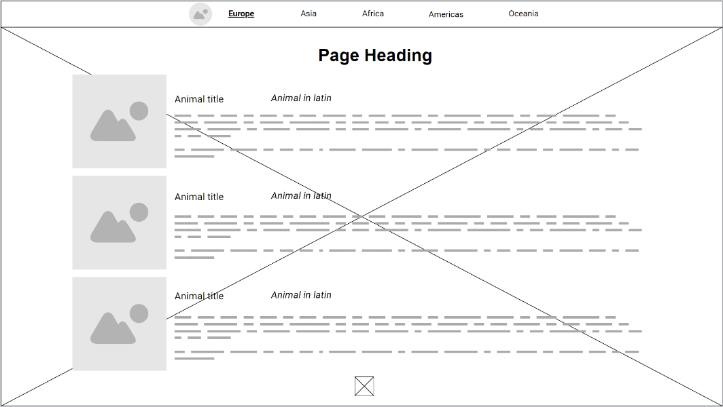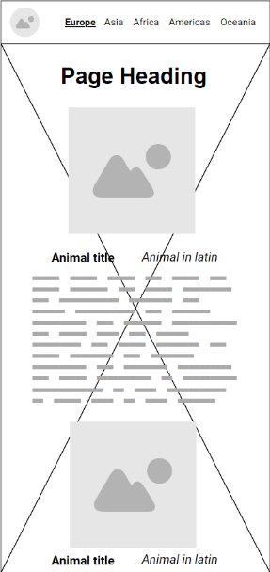

In the header you can see the website logo, which also leads to a home page, and 5 pages to navigate to. To make the design more modern and fancier, a picture will be added as a background to every page. List of elements of animals is going to be scrollable. At the bottom there will be an arrow to expand footer with references.

General selection of colors is as follows:

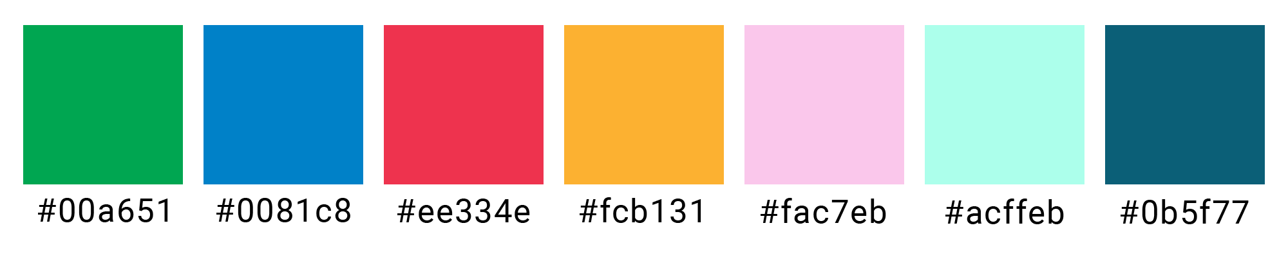

All of them are used to accent the text, first five are representing continents. Selection inspired by Olympic rings[1,2].

Font was selected to be Roboto of various weight.

The layout was chosen to be easy to navigate and simplistic, while also accommodating the most possible information. Footer was chosen to be a pop up, to take less space when less needed and make only one element on the page scrollable, with header and footer fixed.

Implementation also added a blurred, semi-transparent layer below the animal information cards, for improved readability and contrast against the image background. The header was also made semi-transparent, so background can be seen through it, so it unites the page together. Navigation list was also replaced on a mobile by ‘hamburger’ icon, for better size and fit.

To test my website for markup standards I used <https://validator.w3.org/>. I also tested adaptability of my website to a mobile device and different screen sizes in general, using both built in Chrome developer features and a separate mobile device.

Originally, I tested the website on Google Crome, but then also did it on Microsoft Edge, where it looked just as good. Website was also checked on Safari and Opera, showing to be operational and styled the same.

[1]<https://olympics.com/ioc/olympic-rings>

[2]<https://www.google.com/url?sa=i&url=https%3A%2F%2Fwww.flagcolorcodes.com%2Folympic-rings-flag&psig=AOvVaw0UaFQiKGBz7kVxg9uwPJ5Y&ust=1709150759240000&source=images&cd=vfe&opi=89978449&ved=0CBQQjhxqFwoTCLD0nvCozIQDFQAAAAAdAAAAABAE>